Client project (market analysis)
Task:
1. What are the top 10 aisles with the highest number of products?
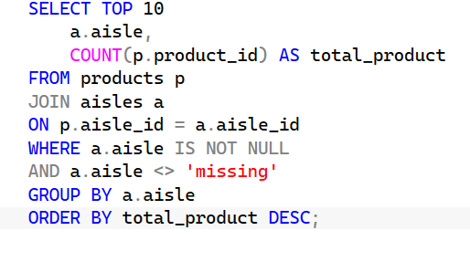
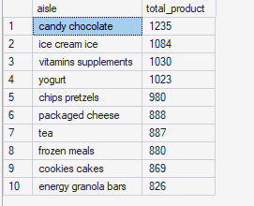
2. How many unique departments are there in the dataset?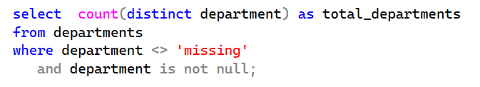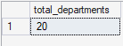
3. What is the distribution of products across departments?
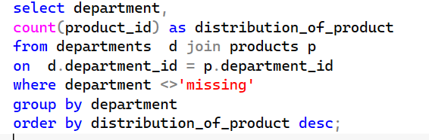
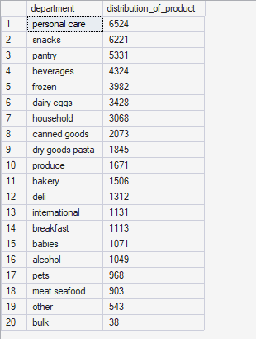

4. What are the top 10 products with the highest reorder rates?
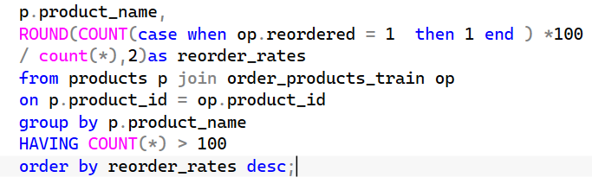
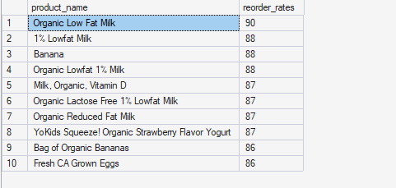
5. How many unique users have placed orders in the dataset?
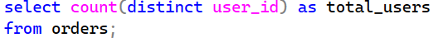
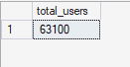
6. What is the average number of days between orders for each user?
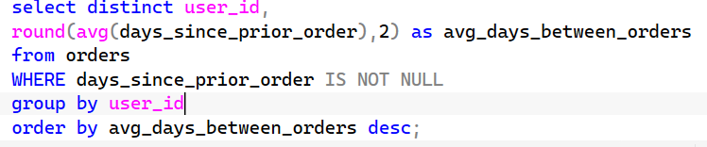
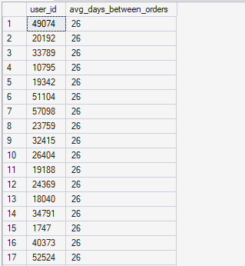
7. What are the peak hours of order placement during the day?
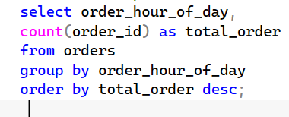
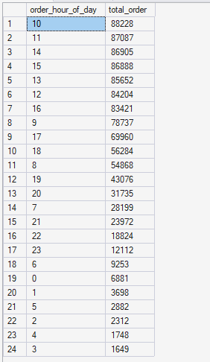
8. How does order volume vary by day of the week?
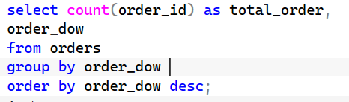
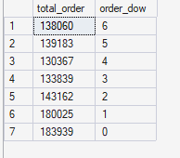

9. What are the top 10 most ordered products?
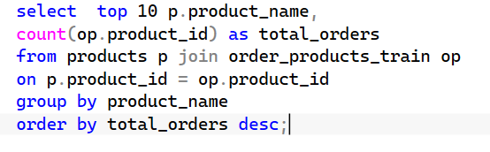
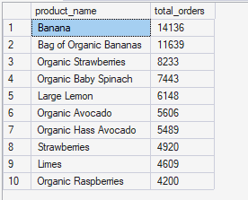
10. How many users have placed orders in each department?
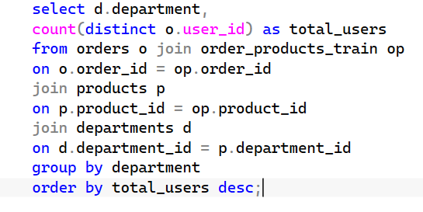
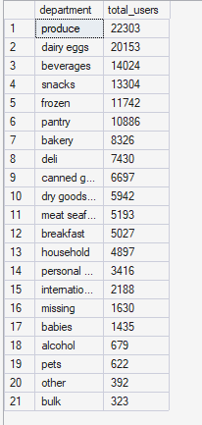
11. What is the average number of products per order?
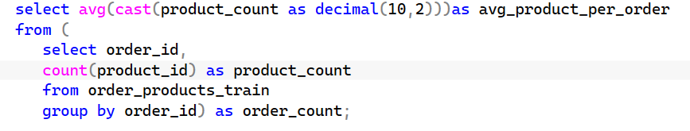
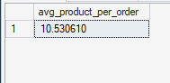
12. What are the most reordered products in each department?
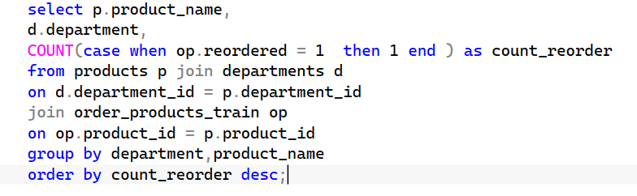
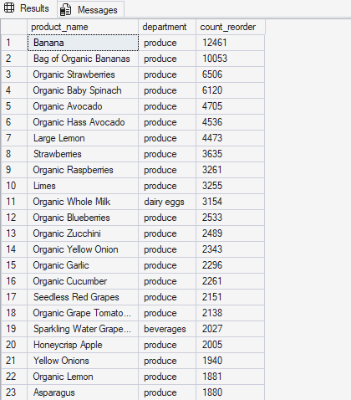
Alternative query
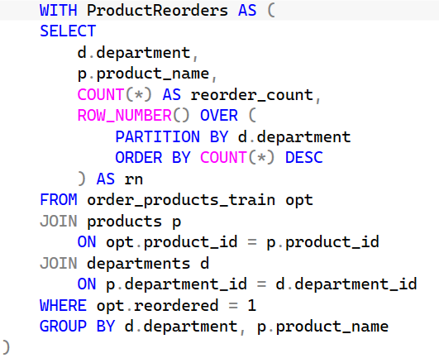
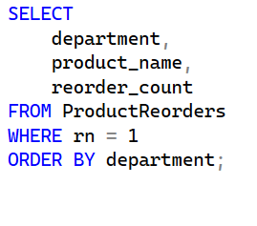
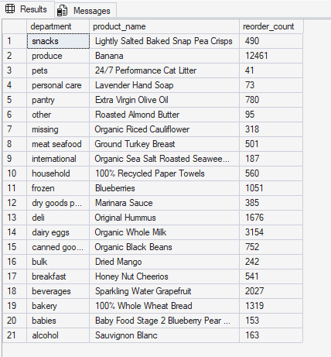
13. How many products have been reordered more than once?
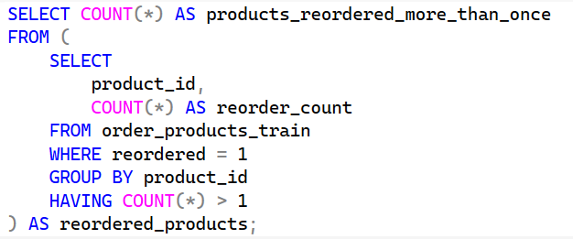
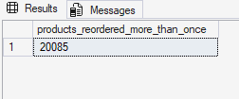
14. What is the average number of products added to the cart per order?
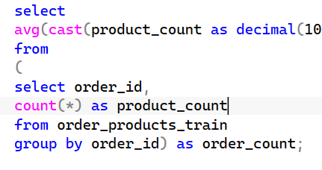
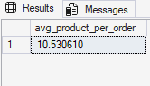
--------------------------------------Alternatives
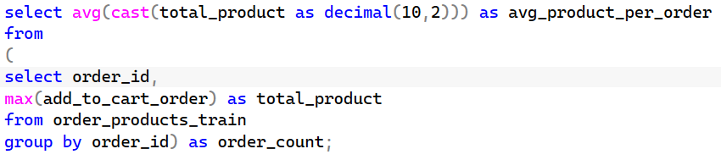
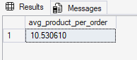

15. How does the number of orders vary by hour of the day?
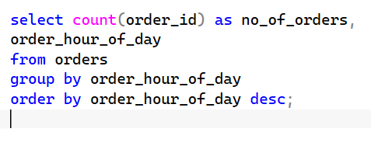
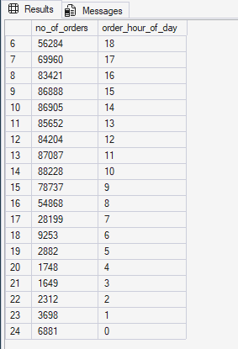
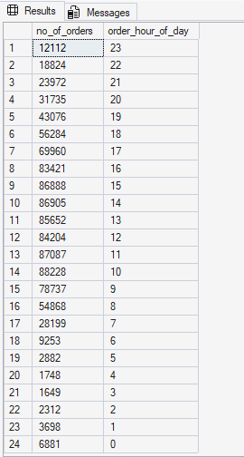
16. What is the distribution of order sizes (number of products per order)?
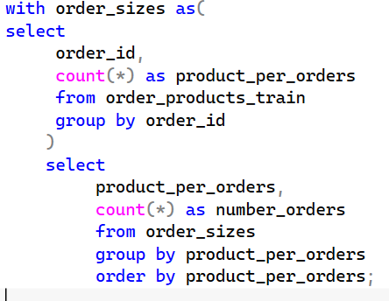
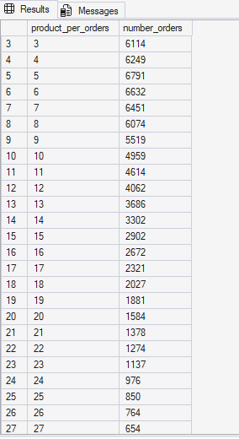
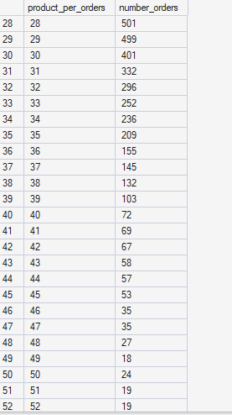
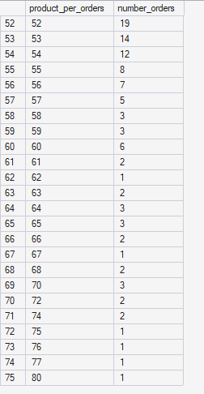
17. What is the average reorder rate for products in each aisle?
Reorder Rate= (Reordered Items​ / Total Items) *100
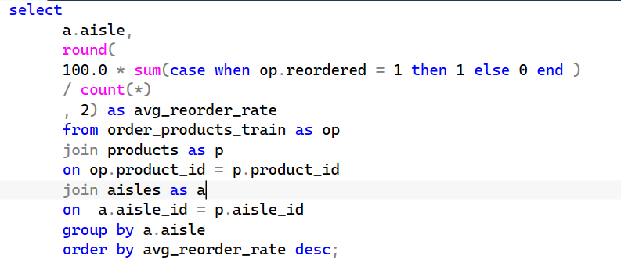
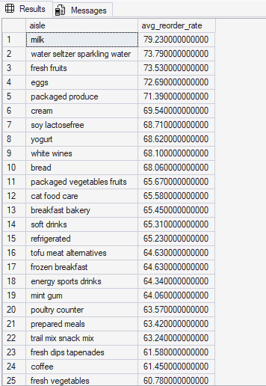
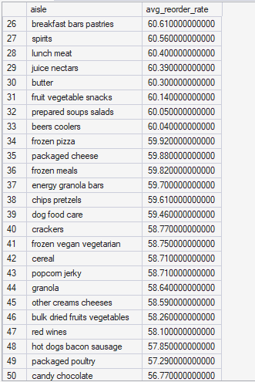
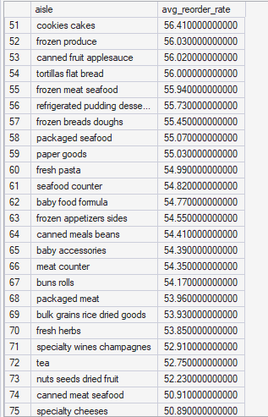
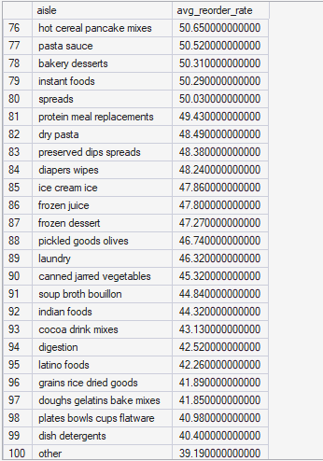
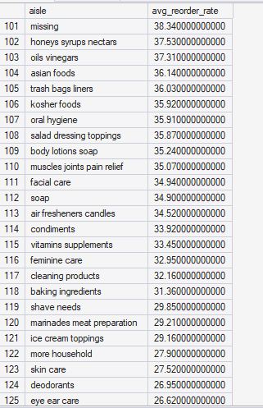
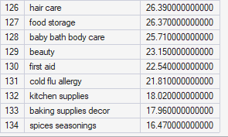
18. How does the average order size vary by day of the week?

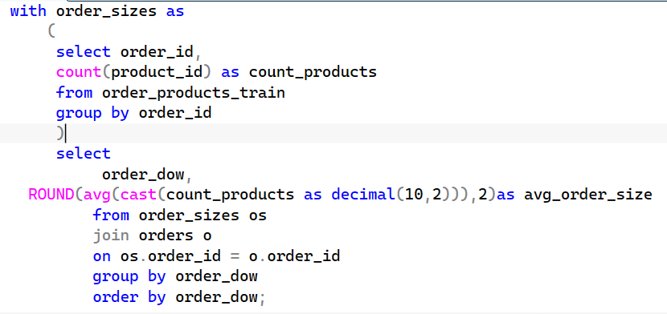
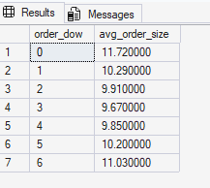
19. What are the top 10 users with the highest number of orders?
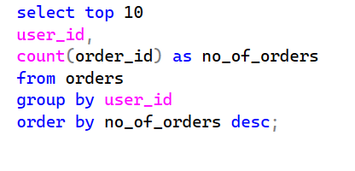
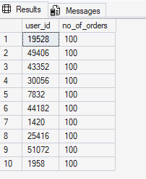
20. How many products belong to each aisle and department?
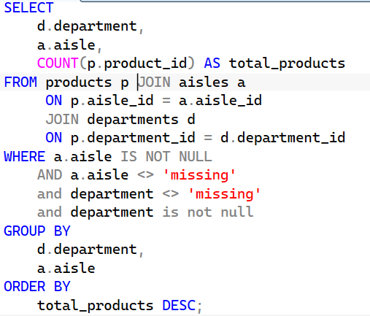
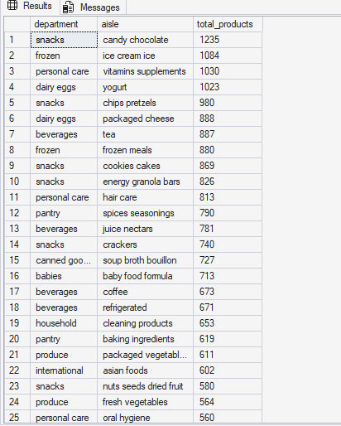
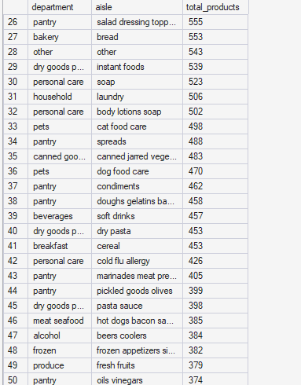
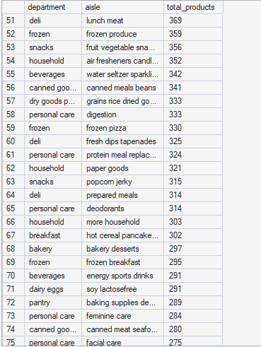
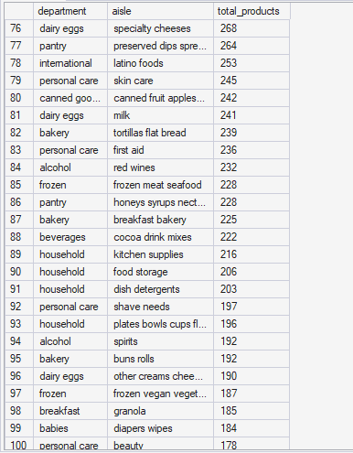
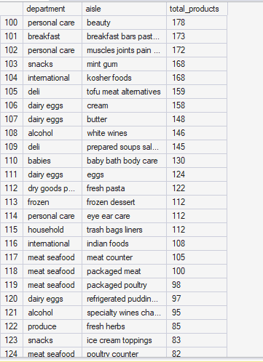
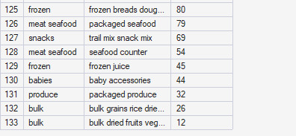

Also, analyze customer purchasing behavior and product performance to optimize marketing strategies and improve customer satisfaction.
can be broken down into business questions and SQL analyses.
Key Areas of Analysis
1. Customer Purchasing Behavior
- Top Customers by Number of Orders
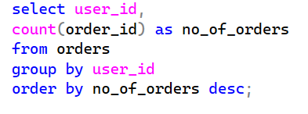
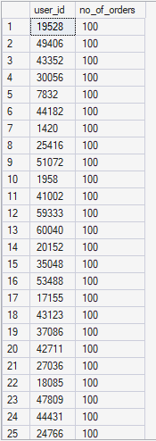

- Average Order Size
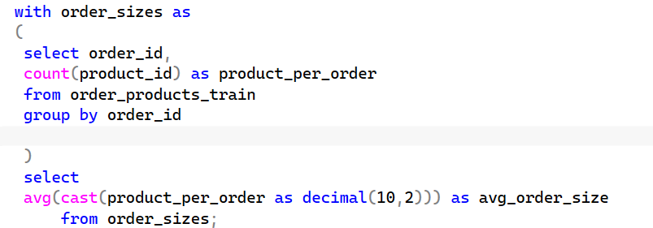
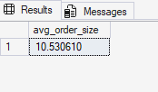

- Orders by Day of Week

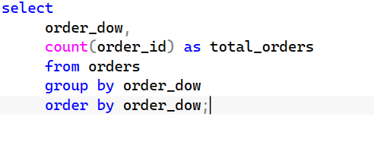
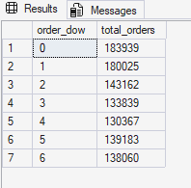

- Orders by Hour of Day
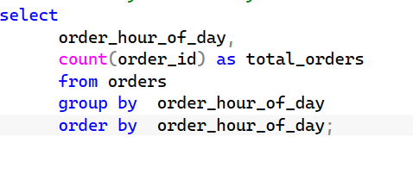
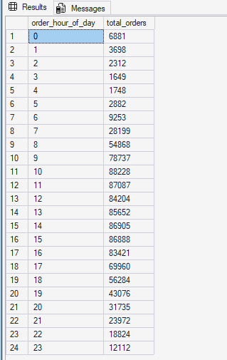
2. Product Performance
- Top 10 Most Ordered Products
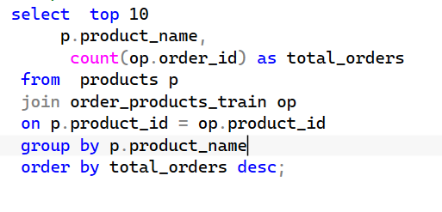
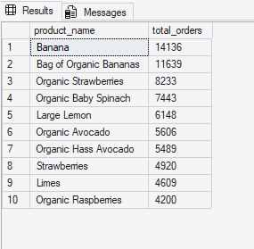
- Top Reordered Products
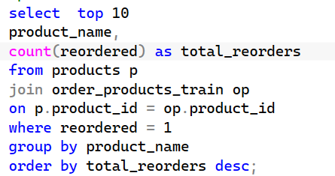
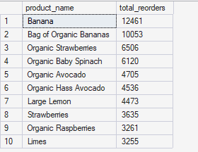
- Reorder Rate by Product
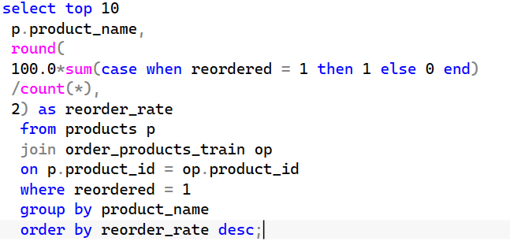
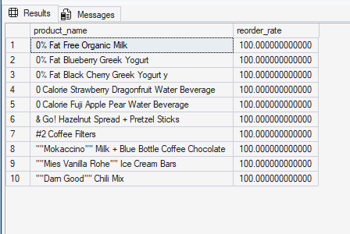
3. Department & Aisle Analysis
- Products per Department
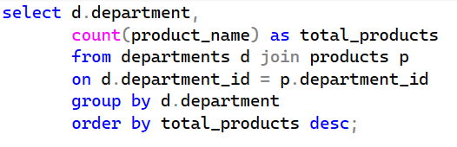
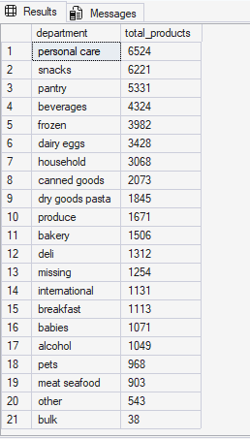

- Average Reorder Rate by Aisle
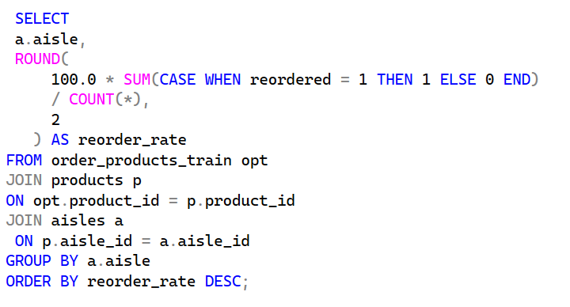
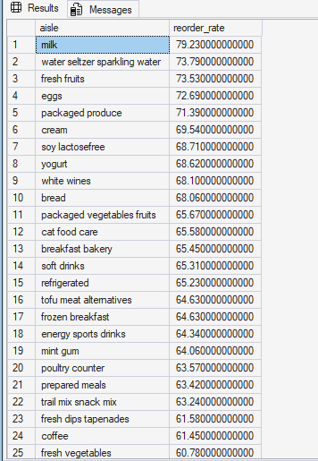
4. Customer Retention & Loyalty
- Users with Highest Reorders

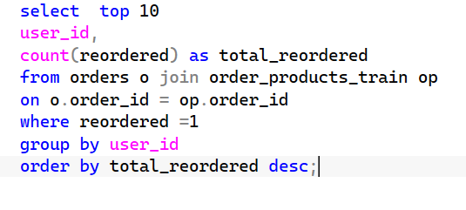
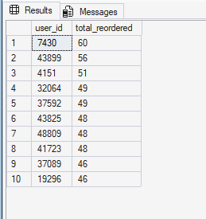
- Days Between Orders
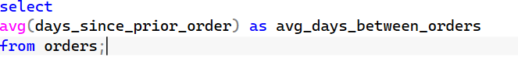
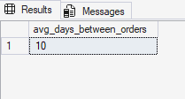

- Business Insights
After analysis, we can draw conclusions such as:
- Customer Behavior
- Most orders are placed during morning and afternoon hours.
- Weekend orders are generally larger than weekday orders.
- A small group of customers contributes a large share of total orders.
- Product Performance
- Frequently reordered products indicate strong customer loyalty.
- Some aisles have significantly higher reorder rates.
- High-volume products should receive priority inventory management.
- Marketing Recommendations
- Target loyal customers with personalized offers.
- Promote products with high reorder rates through recommendation engines.
- Schedule marketing campaigns during peak ordering hours.
- Create bundle offers for products often purchased together.
- Customer Satisfaction Improvements
- Ensure stock availability for top reordered products.
- Improve recommendations based on previous purchases.
- Focus promotions on high-performing departments and aisles.
- Reduce reorder friction by highlighting frequently purchased items.

